
SRM Institute of Science and Technology
Mode of Exam
OFFLINE
SET B

College of Engineering and Technology
DEPARTMENT OF ECE
SRM Nagar, Kattankulathur – 603203, Chengalpattu District, Tamilnadu
Academic Year: 2022-2023 (ODD)
Test: CLAT- II Date: 14/10/2022 Duration: 1 hour 40 Minutes
Course Code & Title: 18ECC203J - Microprocessor, Microcontroller and Interfacing Techniques Year & Sem: III / V Max. Marks: 50

Course Articulation Matrix:
 | 18ECC203J - Microprocessor, Microcontroller and Interfacing Techniques | Program Outcomes (POs)
 |  | Graduate Attributes |  |  |  |  |  |  |  |  |  |  |  |  | PSO
Cos | Course Outcomes (COs) | 1 | 2 | 3 | 4 | 5 | 6 | 7 | 8 | 9 | 10 | 11 | 12 | 1 |  | 2 | 3
CO-1 : | Apply a basic concept of digital fundamentals to Microprocessor based personal computer system | - | 2 | - | - | - | - | - | - | - | - | - | - | - |  | - | -
CO-2 : | Demonstrate programming proficiency using the various addressing modes of the 8086 microprocessor | - | 3 | - | - | 2 | - | - | - | - | - | - | 2 | - |  | - | -
CO-3 : | Develop interfacing techniques using various peripheral chips with microprocessor | - | 2 | 3 | - | 3 | - | - | - | - | - | - | - | - |  | - | 1
CO-4 : | Evaluate programming proficiency using the various addressing modes of the 8051 microcontroller | - | 3 | - | - | 2 | - | - | - | - | - | - | 2 | - |  | - | -
CO-5 : | Construct a system to interface various peripheral chips with microcontroller | - | 2 | 3 | - | 3 | - | - | - | - | - | - | - | - |  | - | 3
CO-6 : | Implement the practical knowledge through laboratory experiments using microprocessor and microcontroller | - | - | 3 | - | 3 | - | - | - | - | - | - | 2 | 1 |  | - | 2

Part – A (10x1 = 10 Marks)
Answer all the questions
Q. No | Question | Marks | BL | CO | PO
 | A - CF & OF | 1 | 1 | 2 | 12
 | D- XLAT | 1 | 2 | 2 | 2
 | A - 35254 H | 1 | 3 | 2 | 12
 | B - 0 | 1 | 1 | 2 | 2
 | C- CALL, RET | 1 | 1 | 2 | 2
 | B - port B to data bus | 1 | 2 | 3 | 2
 | A - Interrupt Request Register | 1 | 1 | 3 | 3
 | B - 0,0,1 | 1 | 1 | 3 | 5
 | C- conversion delay | 1 | 2 | 3 | 2
 | A. handshaking signals | 1 | 2 | 3 | 12
Part – B Section B1 (2 x 10 = 20 Marks)
Instructions: Answer ANY 2 Questions
11 | 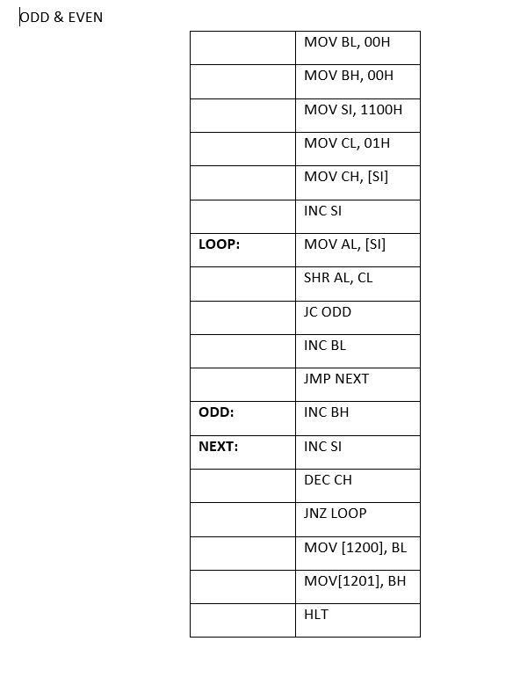 | 10 | 3 | 2 | 2
12 | 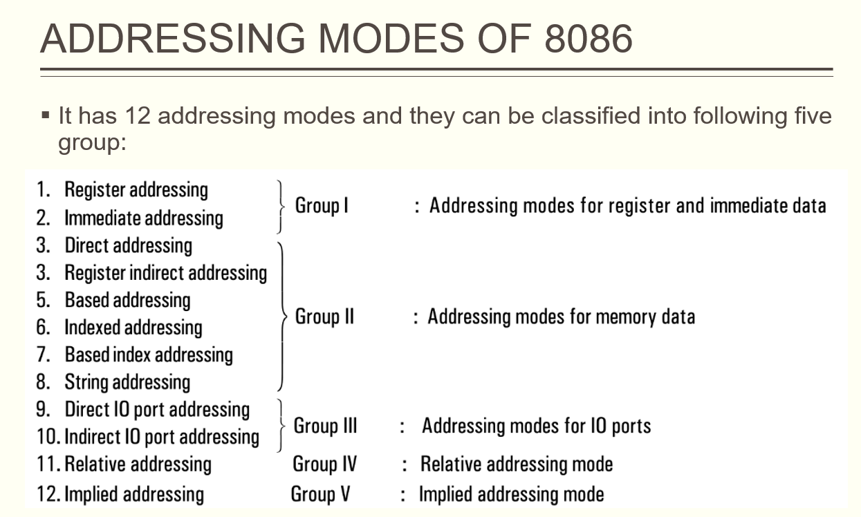  Explanation with relevant examples | 10 | 2 | 2 | 2
13 | The following instructions come under arithmetic and logical instructions:  ADD, ADC, SUB, SBB, INC, DEC, NEG, CMP, MUL, DIV, DAA, DAS, AAA, AAS, AND, OR, XOR, Test.  Answer any 5 each two marks. | 10 | 3 | 2 | 2
Part – B Section B2 (2 x 10 = 20 Marks)
Instructions: Answer ANY 2 Questions
14 | 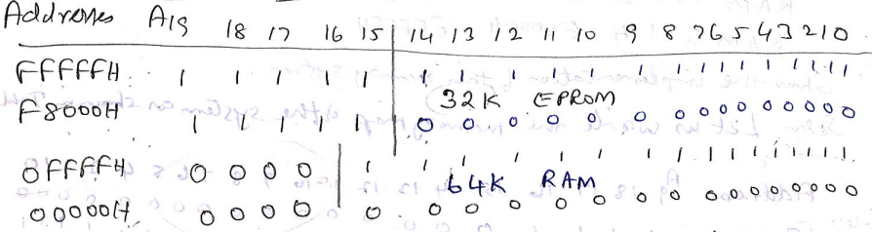  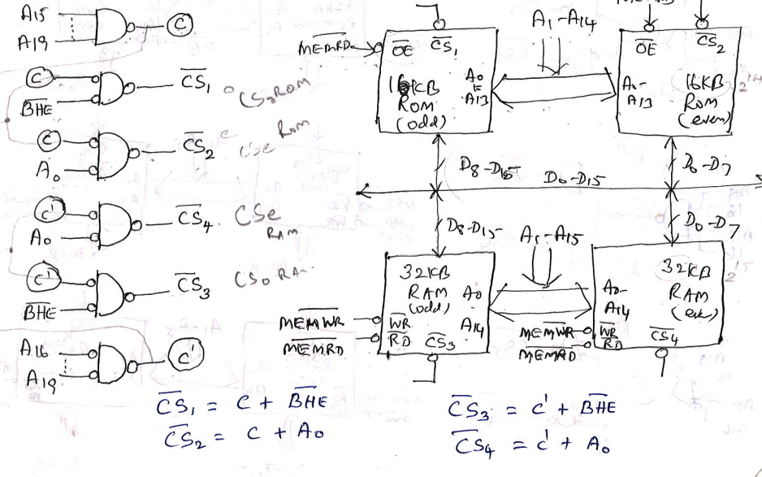  Address Mapping: 05 Marks  Interfacing Diagram : 05 Marks | 10 | 3 | 3 | 3
15 | 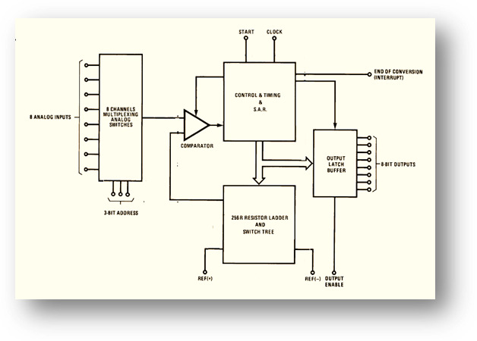  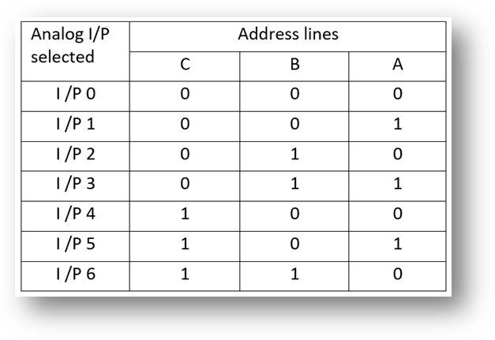  Diagram :05  Explanation :05 | 10 | 3 | 3 | 3
16 | 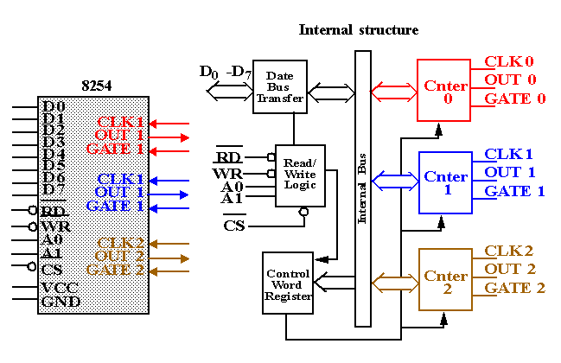  - Mode 0: Interrupt On Terminal Count  - Mode 1: Hardware Retriggerable One-shot  - Mode 2: Rate Generator  - Mode 3: Square Wave Mode  - Mode 4: Software Triggered Strobe  - Mode 5: Hardware Triggered Strobe (Retriggerable)  Mode 0:  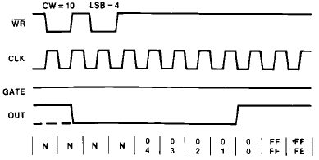  Mode 1:  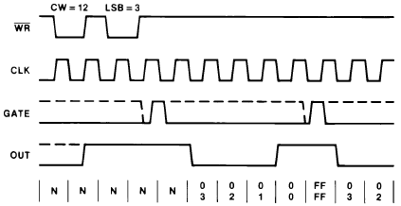  Architecture: 05 Marks  Timing Diagram: 05 Marks | 10 | 2 | 3 | 3

Course Outcome (CO) and Bloom’s level (BL) Coverage in Questions

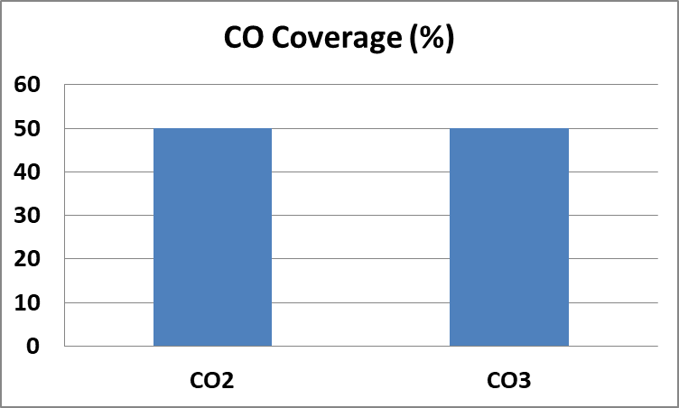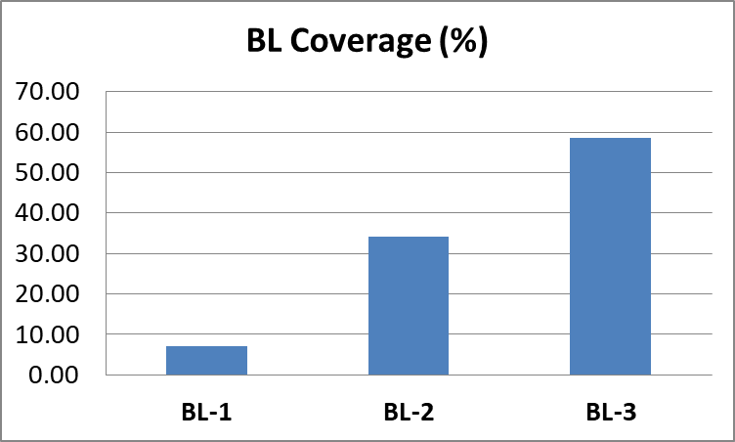

Approved by the Course Coordinator Signature of the Question paper setter

Evaluation Sheet
Name of the Student: Register No.:

Part- A (10 x 1= 10Marks)
Q. No | CO | PO | Maximum Marks | Marks Obtained | Total
1 | 2 | 12 | 1
2 | 2 | 2 | 1
3 | 2 | 12 | 1
4 | 2 | 2 | 1
5 | 2 | 2 | 1
6 | 3 | 2 | 1
7 | 3 | 3 | 1
8 | 3 | 3 | 1
9 | 3 | 2 | 1
10 | 3 | 12 | 1
Part- B (2 x 10= 20 Marks)
11 | 2 | 2 | 10
12 | 2 | 2 | 10
13 | 2 | 2 | 10
14 | 3 | 3 | 10
15 | 3 | 3 | 10
16 | 3 | 3 | 10

Consolidated Marks:

CO | Maximum Marks | Marks Obtained
2 | 25
3 | 25
Total

PO | Maximum Marks | Marks Obtained
2 | 25
3 | 42
12 | 03
Total

Signature of Course Teacher

Signature of the Course Coordinator Signature of the Academic Advisor

